**Hubei University of Technology**

**Course Design Report**

**Course Name: Information Management System**

**Student Name: AHMED MD JUBAIR**

**Student Class: CST 19lq**

**Student Number: 1911521211**

**November 2022**

# ACKNOWLEDGEMENT

We take this occasion to thank God, almighty for blessing us with his grace and taking our endeavor to a successful culmination. We extend our sincere and heartfelt thanks to our esteemed guide, for providing us with the right guidance and advice at the crucial junctures and for showing me the right way. Last but not the least, we would like to thank our friends and family for the support and encouragement they have given us during the course of our work.

## TABLE OF CONTENTS

ABSTRACT 5

1. INTRODUCTION 6
   1. PROJECT AIMS AND OBJECTIVES 6
   2. BACKGROUND OF PROJECT 7
   3. OPERATION ENVIRONMENT 8
2. SYSTEM ANALYSIS 9
   1. SOFTWARE REQUIREMENT SPECIFICATION 9
   2. EXISTING VS PROPOSED 15
   3. SOFTWARE TOOL USED 16
3. SYSTEM DESIGN 20
   1. TABLE DESIGN 20
   2. DATA FLOW DIAGRAM’S 24
4. SYSTEM IMPLEMENTATION 30
   1. MODULE DESCRIPTION 30
   2. SCREEN SHOTS 80
5. SYSTEM TESTING 85
   1. UNIT TESTING 85
   2. INTEGRATION TESTING 87
6. CONCLUSION & FUTURE SCOPE 88
7. REFERENCES 89

#### ABSTRACT

##### Book management system is a project which aims in developing a computerized system to maintain all the daily work of Book .This project has many features which are generally not available in normal Book management systems like facility of user login and a facility of teachers login .It also has a facility of admin login through which the admin can monitor the whole system .It also has facility of an online notice board where teachers can student can put up information about workshops or seminars being held in our colleges or nearby colleges and librarian after proper verification from the concerned institution organizing the seminar can add it to the notice board . It has also a facility where student after logging in their accounts can see list of books issued and its issue date and return date and also the students can request the librarian to add new books by filling the book request form. The librarian after logging into his account i.e. admin account can generate various reports such as student report, issue report, teacher report and book report

Overall, this project of ours is being developed to help the students as well as staff of Book to maintain the Book in the best way possible and also reduce the human efforts.

**CHAPTER 1 INTRODUCTION**

This chapter gives an overview about the aim, objectives, background and operation environment of the system.

#### PROJECT AIMS AND OBJECTIVES

The project aims and objectives that will be achieved after completion of this project are discussed in this subchapter. The aims and objectives are as follows:

* + - Online book issue
    - Request column for librarian for providing new books
    - A separate column for digital Book
    - Student login page where student can find books issued by him/her and date of return.
    - A search column to search availability of books
    - A teacher login page where teacher can add any events being organized in the college and important suggestions regarding books.
    - Online notice board about the workshop.

#### BACKGROUND OF PROJECT

Book Management System is an application which refers to Book systems which are generally small or medium in size. It is used by librarian to manage the Book using a computerized system where he/she can record various transactions like issue of books, return of books, addition of new books, addition of new students etc.

Books and student maintenance modules are also included in this system which would keep track of the students using the Book and also a detailed description about the books a Book contains. With this computerized system there will be no loss of book record or member record which generally happens when a non-computerized system is used.

In addition, report module is also included in Book Management System. If user’s position is admin, the user is able to generate different kinds of reports like lists of students registered, list of books, issue and return reports.

All these modules are able to help librarian to manage the Book with more convenience and in a more efficient way as compared to Book systems which are not computerize

## CHAPTER 2

**SYSTEM ANALYSIS**

In this chapter, we will discuss and analyze about the developing process of Book Management System including software requirement specification (SRS) and comparison between existing and proposed system. The functional and nonfunctional requirements are included in SRS part to provide complete description and overview of system requirement before the developing process is carried out. Besides that, existing vs proposed provides a view of how the proposed system will be more efficient than the existing one.

#### SOFTWARE REQUIREMENT SPECIFICATION

* + 1. **GENERAL DESCRIPTION**

PRODUCT DESCRIPTION:

Book Management System is a computerized system which helps user(librarian) to manage the Book daily activity in electronic format. It reduces the risk of paper work such as file lost, file damaged and time consuming.

It can help user to manage the transaction or record more effectively and time- saving.

PROBLEM STATEMENT:

The problem occurred before having computerized system includes:

* + - File lost

When computerized system is not implemented file is always lost because of human environment. Sometimes due to some human error there may be a loss of records.

* + - File damaged When a computerized system is not there file is always lost due to some accident like spilling of water by some member on file accidentally. Besides some natural disaster like floods or fires may also damage the files.
    - Difficult to search record

When there is no computerized system there is always a difficulty in searching of records if the records are large in number.

* + - Space consuming

After the number of records become large the space for physical storage of file and records also increases if no computerized system is implemented.

* + - Cost consuming

As there is no computerized system the to add each record paper will be needed which will increase the cost for the management of Book.

#### SYSTEM OBJECTIVES

* + - Improvement in control and performance

The system is developed to cope up with the current issues and problems of Book

.The system can add user, validate user and is also bug free.

* + - Save cost

After computerized system is implemented less human force will be required to maintain the Book thus reducing the overall cost.

* + - Save time

Librarian is able to search record by using few clicks of mouse and few search keywords thus saving his valuable time.

* + - Option of online Notice board

Librarian will be able to provide a detailed description of workshops going in the college as well as in nearby colleges

* + - Lecture Notes

Teacher have a facility to upload lectures notes in a pdf file having size not more than 10mb

#### SYSTEM REQUIREMENTS

* + - 1. NON FUNCTIONAL REQUIREMENTS
         * Product Requirements EFFICIENCY REQUIREMENT

When a Book management system will be implemented librarian and user will easily acess Book as searching and book transaction will be very faster .

RELIABILITY REQUIREMENT

The system should accurately performs member registration ,member validation , report generation, book transaction and search

USABILITY REQUIREMENT

The system is designed for a user friendly environment so that student and staff of Book can perform the various tasks easily and in an effective way.

ORGANIZATIONAL REQUIREMENT IMPLEMENTATION REQUIREMNTS

In implementing whole system it uses html in front end with php as server side scripting language which will be used for database connectivity and the backend ie the database part is developed using mysql.

DELIVERY REQUIREMENTS

The whole system is expected to be delivered in six months of time with a weekly evaluation by the project guide.

* + - 1. FUNCTIONAL REQUIREMENTS

1. NORMAL USER
   1. USER LOGIN Description of feature

This feature used by the user to login into system. They are required to enter user id and password before they are allowed to enter the system .The user id and password will be verified and if invalid id is there user is allowed to not enter the system.

Functional requirements

-user id is provided when they register

-The system must only allow user with valid id and password to enter the system

-The system performs authorization process which decides what user level can acess to.

-The user must be able to logout after they finished using system.

* 1. REGISTER NEW USER

Description of feature

This feature can be performed by all users to register new user to create account.

Functional requirements

-System must be able to verify information

-System must be able to delete information if information is wrong

* 1. REGISTER NEW BOOK Description of feature

This feature allows to add new books to the Book Functional requirements

-System must be able to verify information

-System must be able to enter number of copies into table.

- System must be able to not allow two books having same book id.

1.5 SEARCH BOOK

DESCRIPTION OF FEATURE

This feature is found in book maintenance part . we can search book based on book id , book name , publication or by author name.

Functional requirements

* System must be able to search the database based on select search type
* System must be able to filter book based on keyword enterd
* System must be able to show the filtered book in table view
  1. ISSUE BOOKS AND RETURN BOOKS

DESCRIPTION OF FEATURE

This feature allows to issue and return books and also view reports of book issued.

Functional requirements

-System must be able to enter issue information in database.

-System must be able to update number of books.

- System must be able to search if book is available or not before issuing books

-System should be able to enter issue and return date information

* 1. EVENT ADDITION

DESCRIPTION OF FEATURE

This feature allows teacher and student to add information about various workshops being conducted in college and colleges nearby.

Functional requirements

-System should be able to add detailed information about events .

-System should be able to display information on notice board available in the homepage of site

#### SOFTWARE AND HARDWARE REQUIREMENTS

This section describes the software and hardware requirements of the system

* + - 1. SOFTWARE REQUIREMENTS
         * Operating system- Windows 7 is used as the operating system as it is stable and supports more features and is more user friendly
         * Database MYSQL-MYSQL is used as database as it easy to maintain and retrieve records by simple queries which are in English language which are easy to understand and easy to write.
         * Development tools and Programming language- HTML is used to write the whole code and develop webpages with css, java script for styling work and php for sever side scripting.
      2. HARDWARE REQUIREMENTS
* Intel core i5 2nd generation is used as a processor because it is fast than other processors an provide reliable and stable and we can run our pc for longtime. By using this processor we can keep on developing our project without any worries.
* Ram 1 gb is used as it will provide fast reading and writing capabilities and will in turn support in processing

#### SOFTWARE TOOLS USED

The whole Project is divided in two parts the front end and the back end.

* + 1. Front end

The front end is designed using of html , Php ,css, Java script

* + - * + HTML- **HTML** or **Hyper Text Markup Language** is the main markup language for creating web pages and other information that can be displayed in a web browser.HTML is written in the form of HTML elements consisting of *tags* enclosed in angle brackets (like <html>), within the web page content. HTML tags most commonly come in pairs like <h1> and </h1>, although some tags represent *empty elements* and so are unpaired, for example <img>. The first tag in a pair is the *start tag*, and the second tag is the *end tag* (they are also called *opening tags* and *closing tags*). In between these tags web designers can add text, further tags, comments and other types of text-based content. The purpose of a web browser is to read HTML documents and compose them into visible or audible web pages. The browser does not display the HTML tags, but uses the tags to interpret the content of the page.HTML elements form the building blocks of all websites. HTML allows images and objects to be embedded and can be used to create interactive forms. It provides a means to create structured

documents by denoting structural semantics for text such as headings, paragraphs, lists, links, quotes and other items. It can embed scripts written in languages such as JavaScript which affect the behavior of HTML web pages.

* + - * + CSS- **Cascading Style Sheets** (**CSS**) is a style sheet language used for describing the look and formatting of a document written in a markup language. While most often used to style web pages and interfaces written in HTML and XHTML, the language can be applied to any kind

of XML document, including plain XML, SVG and XUL. CSS is a cornerstone specification of the web and almost all web pages use CSS style sheets to describe their presentation.CSS is designed primarily to enable the separation of document content from document presentation, including elements such as the layout, colors, and fonts. This separation can improve content accessibility, provide more flexibility and control in the specification

of presentation characteristics, enable multiple pages to share formatting, and reduce complexity and repetition in the structural content (such as by allowing for table less web design).CSS can also allow the same markup page to be presented in different styles for different rendering methods, such as on-screen, in print, by voice (when read out by a speech-based browser or screen reader) and on Braille-based, tactile devices. It can also be used to allow the web page to display differently depending on the screen size or device on which it is being viewed. While the author of a document typically links that document to a CSS file, readers can use a different style sheet, perhaps one on their own computer, to override the one the author has specified. However if the author or the reader did not link the document to a specific style sheet the default style of the browser will be applied.CSS specifies a priority scheme to determine which style rules apply if more than one rule matches against a particular element. In this so-called *cascade*, priorities or *weights* are calculated and assigned to rules, so that the results are predictable.

* + - * + JAVA SCRIPT- **JavaScript** (**JS**) is a dynamic computer programming language. It is most commonly used as part of web browsers, whose implementations allow client-side scripts to interact with the user, control the browser, communicate asynchronously, and alter the document content that is displayed. It is also being used in server-side programming, game development and the creation of desktop and mobile applications. JavaScript is a prototype-based scripting language with dynamic typing and has first- class functions. Its syntax was influenced by C. JavaScript copies many names and naming conventions from Java, but the two languages are otherwise unrelated and have very different semantics. The key design principles within JavaScript are taken from

the Self and Scheme programming languages. It is a multi- paradigm language, supporting object-oriented, imperative,

and functional programming styles. The application of JavaScript to use outside of web pages—for example, in PDF documents, site-specific browsers, and desktop widgets—is also significant. Newer and faster JavaScript VMs and platforms built upon them (notably Node.js) have also increased the popularity of JavaScript for server-side web applications. On the client side, JavaScript was traditionally implemented as

an interpreted language but just-in-time compilation is now performed by recent (post-2012) browsers.

* + - * + PHP- **PHP** is a server-side scripting language designed for web development but also used as a general-purpose programming language. PHP is now installed on more than 244 million websites and 2.1 million web servers. Originally created by Rasmus Lerdorf in 1995, the reference implementation of PHP is now produced by The PHP Group. While PHP originally stood for *Personal Home Page*, it now stands for *PHP: Hypertext Preprocessor*, a recursive backronym.PHP code is interpreted by a web server with a PHP processor module, which generates the resulting web page: PHP commands can be embedded directly into an HTML source document rather than calling an external file to process data. It has also evolved to include a command-line interface capability and can be used

in standalone graphical applications. PHP is free software released under the PHP License. PHP can be deployed on most web servers and also as a standalone shell on almost every operating system and platform, free of charge.

* + 1. BACK END- The back end is designed using mysql which is used to design the databases
* MYSQL- **MySQL** ("My S-Q-L", officially, but also called "My Sequel") is (as of July 2013) the world's second most widely used open-source relational database management system (RDBMS). It is named after co-founder Michael Widenius daughter, My. The SQL phrase stands for Structured Query Language. The MySQL development project has made its source code available under the terms of the GNU General Public License, as well as under a variety

of proprietary agreements. MySQL was owned and sponsored by a single for- profit firm, the Swedish company MySQL AB, now owned by Oracle Corporation

.MySQL is a popular choice of database for use in web applications, and is a central component of the widely used LAMP open source web application software stack (and other 'AMP' stacks). LAMP is an acronym for "Linux, Apache,

MySQL, Perl/PHP/Python." Free-software-open source projects that require a full-featured database management system often use MySQL. For commercial use, several paid editions are available, and offer additional functionality.

Applications which use MySQL databases

include: TYPO3, MODx, Joomla, WordPress, phpBB, MyBB, Drupal and other software. MySQL is also used in many high-profile, large-scale websites, including Wikipedia, Google (though not for

searches), Facebook, Twitter, Flickr, and YouTube

## CHAPTER 3 SYSTEM DESIGN

#### TABLE DESIGN

VARIOUS TABELS TO MAINTAIN INFORMATION

* + - BOOK TABLE FOR KEEPING TRACK OF BOOKS

|  |  |  |  |  |
| --- | --- | --- | --- | --- |
| **Field** | **Data type** | **Default** | **Key** | **Extra** |
| Code | INT(11) | Not Null | Primary | Auto increment |
| Bookname | VARCHAR(255) | Null |  |  |
| Author | VARCHAR(255) | Null |  |  |
| Publication | VARCHAR(255) | Null |  |  |
| Subject | VARCHAR(255) | Null |  |  |
| No of copies | INT(10) | Null |  |  |

* STUDENT TABLE FOR STUDENT INFORMATION

|  |  |  |  |  |
| --- | --- | --- | --- | --- |
| **Field** | **Data type** | **Default** | **Key** | **Extra** |
| libid | INT(11) | NOT NULL | Primary key | Auto increment |
| regno | INT(10) | NULL |  |  |
| branch | VARCHAR(255) | NULL |  |  |
| section | VARCHAR(255) | NULL |  |  |
| semester | VARCHAR(255) | NULL |  |  |
| section | VARCHAR(2) | NULL |  |  |
| yearofadm | INT(5) | NULL |  |  |

* Issue table to keep track of books issued

|  |  |  |  |  |
| --- | --- | --- | --- | --- |
| **Field** | **Data Type** | **Default** | **Key** | **Extra** |
| bookid | INT(11) | NOT NULL | Foreign key | References book |
| stuid | INT(11) | NOT NULL | Foreign key | References Student |
| issuedate | DATE | NULL |  |  |
| returndate | DATE | NULL |  |  |

* STUDENT LOGIN TABLE

|  |  |  |  |  |
| --- | --- | --- | --- | --- |
| **Field** | **Data type** | **Default** | **Key** | **Extra** |
| logid | INT(11) | NOT NULL | Foreign key | References Student |
| Username | VARCHAR(255) | NULL |  |  |
| Password | VARCHAR(255) | NULL |  |  |
| numbooks | INT(1) | NULL |  |  |

DATA FLOW DIAGRAM FOR BOOK ISSUE

LOGIN

DATABASE

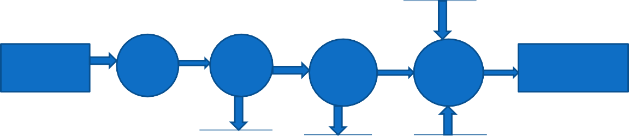

STUDENT

LOGIN

PAGE

SELECT

BOOK

ISSUE

ENTER

BOOK

DETAIL

IF

AVBL

SELECT

BOOK ISSUE

IF NO.

OF

BOOK

ISSUED LESS THAN

3

UPDATE

NO. OF

COPIES

MESSAGE

“BOOK

RESERVED”

BOOK

DATABASE

LOGIN

TABLE

BOOK

DATABASE

It is a 2nd level Data Flow Diagram where after entering STUDENT LOGIN page he/she can select a book issue option where after entering the book detail, he/she can select the book issue option and if the maximum no of books issued limit is not crossed then a request will be sent to the librarian who will approve the book issue.

## CHAPTER 4

**SYSTEM IMPLEMENTATION**

**4.1.1 Screenshot for homepage**

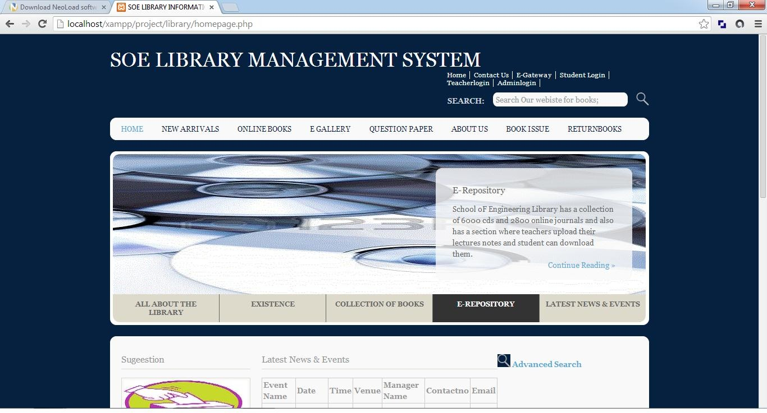

#### MODULE DESCRIPTION

For Book Management System it is divided into the following Modules:

#### Admin Module

BOOK ADDITION

REPORT GENERATION

TEACHER REGISTRATION

ADMIN

STUDENT VALIDATION

The following module contains various facilities like student validation, teacher registration, book addition, and report generation.

**4**

* + - 1. **Code for checking of admin username and password information**

<?php

session_start();

$host="localhost"; // Host name

$username="root"; // Mysql username

$password=""; // Mysql password

$db_name="admin"; // Database name

$tbl_name="adminlogin"; // Table name

// Connect to server and select databse.

mysql_connect("$host", "$username", "$password")or die("cannot connect"); mysql_select_db("$db_name")or die("cannot select DB");

// username and password sent from form

$myusername=$_POST['username'];

$mypassword=$_POST['password'];

$sql="SELECT * FROM $tbl_name WHERE username='$myusername' and password='$mypassword'";

$result=mysql_query($sql);

// Mysql_num_row is counting table row

$count=mysql_num_rows($result);

// If result matched $myusername and $mypassword, table row must be 1 row if($count>0)

{ session_regenerate_id();

$member = mysql_fetch_assoc($result);

$_SESSION['SESS_FIRST_NAME'] = $member['username'];

$_SESSION['SESS_LAST_NAME'] = $member['password']; session_write_close();

header("location: adminlogin1.php"); exit();

}else {

//Login failed

$errmsg_arr[] = 'user name and password not found';

$errflag = true; if($errflag) {

$_SESSION['ERRMSG_ARR'] = $errmsg_arr; session_write_close();

header("location: adminlogin.php"); exit();

}

}

?>

#### Code for book addition

<?php

$con=mysqli_connect("localhost","root","","Book");

// Check connection

if (mysqli_connect_errno())

{

echo "Failed to connect to MySQL: " . mysqli_connect_error();

}

$sql="INSERT INTO books (code, bookname, author, publication, subject, numberofbooks)

VALUES

('$_POST[bookid]','$_POST[bookname]','$_POST[author]','$_POST[publication]','$_P OST[subject]','$_POST[numberofbooks]')";

if (!mysqli_query($con,$sql))

{

echo "error";

}

echo "successs";

mysqli_close($con);

?>

<?php

$con=mysqli_connect("localhost","root","","admin");

// Check connection

if (mysqli_connect_errno())

{

echo "Failed to connect to MySQL: " . mysqli_connect_error();

}

$sql="INSERT INTO newarrivals (code, bookname, author, publication, subject, numberofbooks,arrivaldate)

VALUES

('$_POST[bookid]','$_POST[bookname]','$_POST[author]','$_POST[publication]','$_P OST[subject]','$_POST[numberofbooks]','$_POST[arrivaldate]')";

if (!mysqli_query($con,$sql))

{

echo "error";

}

echo "successs"; mysqli_close($con);

?>

* + 1. **Screenshot for Admin login**

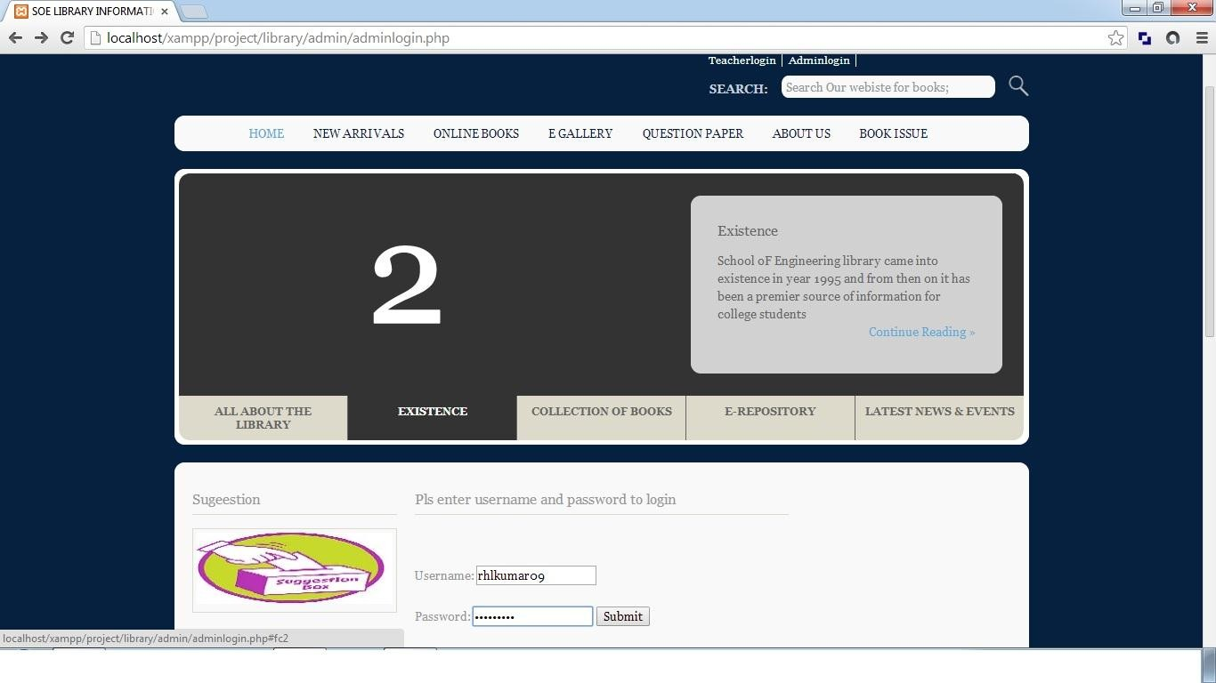

#### Student Module

STUDENT

ONLINE BOOK RESERVATTION

EVENT ADDITION

STUDENT LOGIN

FORGOT PASSWORD

USERNAME AND PASSWORD

AUTHENTICATION

STUDENT REGISTRATION

The following module contains various facilities like student registration, student login, online book reservation, and event addition. Any student if at any moment forgets his password he can retrieve it from forgot password option.

#### Code For Student account creation

<!DOCTYPE html>

<html xml:lang="EN" lang="EN" dir="ltr">

<head>

<title>SOE BOOK INFORMATION SYSTEM</title>

<meta http-equiv="Content-Type" content="text/html; charset=iso-8859-1" />

<meta http-equiv="imagetoolbar" content="no" />

<link rel="stylesheet" href="../styles/layout.css" type="text/css" />

<!-- Homepage Specific Elements -->

<script type="text/javascript" src="../scripts/jquery-1.4.1.min.js"></script>

<script type="text/javascript" src="../scripts/jquery-ui- 1.7.2.custom.min.js"></script>

<script type="text/javascript" src="../scripts/jquery.tabs.setup.js"></script>

<!-- End Homepage Specific Elements -->

</head>

<body id="top">

<div class="wrapper row1">

<div id="header" class="clear">

<div class="fl_left">

<h1><a href="homepage.php">SOE BOOK MANAGEMENT SYSTEM</a></h1>

<p></p>

</div>

<div class="fl_right">

<ul>

<li><a href="[http://localhost/xampp/project/Book/homepage.php](http://localhost/xampp/project/library/homepage.php)">Home</a></li>

<li><a href="[http://localhost/xampp/project/Book/contact/Contactus.php](http://localhost/xampp/project/library/contact/Contactus.php)">Contact Us</a></li>

<li><a href="[http://localhost/xampp/project/Book/egateway/egateway.php](http://localhost/xampp/project/library/egateway/egateway.php)">E- Gateway</a></li>

<li><a href="[http://localhost/xampp/project/Book/studentlogin/studentlogin.php"](http://localhost/xampp/project/library/studentlogin/studentlogin.php)>Student Login</a></li>

<li ><a href="[http://localhost/xampp/project/Book/teachrlogin/teacherlogin.php](http://localhost/xampp/project/library/teachrlogin/teacherlogin.php)">Teacherl ogin</a></li>

<li><a href="[http://localhost/xampp/project/Book/admin/adminlogin.php"](http://localhost/xampp/project/library/admin/adminlogin.php)>Adminlogin</a

></li>

</ul>

<form action="#" method="post" id="sitesearch">

<fieldset>

<strong>Search:</strong>

<input type="text" value="Search Our webiste for books;" onfocus="this.value=(this.value=='Search Our website for books;')? '' : this.value ;"

/>

<input type="image" src="../images/search.gif" id="search" alt="Search" />

</fieldset>

</form>

</div>

</div>

</div>

<!-- #################################################################### ################################### -->

<div class="wrapper row2">

<div class="rnd">

<!-- ###### -->

<div id="topnav">

<ul>

<li class="active"><a href="homepage.php">Home</a></li>

<li><a href="newarrivals.php">New Arrivals</a></li>

<li><a href="onlinebooks.php">Online Books</a></li>

<li><a href="egallery.php">E Gallery</a></li>

<li><a href="questionpaper.php">Question Paper</a></li>

<li><a href="aboutus.php">About Us</a></li>

<li><a href="bookissue.php">Book Issue </a></li>

<li class="last"><a href="#"></a></li>

</ul>

</div>

<!-- ###### -->

</div>

</div>

<!-- #################################################################### ################################### -->

<div class="wrapper">

<div id="featured_slide" class="clear">

<!-- ###### -->

<div class="overlay_left"></div>

<div id="featured_content">

<div class="featured_box" id="fc1"><img src="../images/demo/slider/1.gif" alt="" />

<div class="floater">

<h2>All ABOUT SOE BOOK</h2>

<p>School oF Engineering Book or the S.O.E Book is one of the finest Book in kerela having a good collection of books related to various subjects</p>

<p class="readmore"><a href="#">Continue Reading &raquo;</a></p>

</div>

</div>

<div class="featured_box" id= "fc2"><img src="../images/demo/slider/2.gif" alt="" />

<div class="floater">

<h2>Existence</h2>

<p>School oF Engineering Book came into existence in year 1995 and from then on it has been a premier source of information for college students</p>

<p class="readmore"><a href="#">Continue Reading &raquo;</a></p>

</div>

</div>

<div class="featured_box" id="fc3"><img src="../images/demo/slider/3.gif" alt="" />

<div class="floater">

<h2>Collection</h2>

<p>School of Engineering Book has a collection of over 25000 books related to various subjects in engineering</p>

<p class="readmore"><a href="#">Continue Reading &raquo;</a></p>

</div>

</div>

<div class="featured_box" id="fc4"><img src="../images/demo/slider/4.gif" alt="" />

<div class="floater">

<h2>E-Repository</h2>

<p>School oF Engineering Book has a collection of 6000 cds and 2800 online journals and also has a section where teachers upload their lectures notes and student can download them.</p>

<p class="readmore"><a href="#">Continue Reading &raquo;</a></p>

</div>

</div>

<div class="featured_box" id="fc5"><img src="../images/demo/slider/5.gif" alt="" />

<div class="floater">

<h2>Latest News and events</h2>

<p></p>

<p class="readmore"><a href="#">Click here to go to latest news page;</a></p>

</div>

</div>

</div>

<ul id="featured_tabs">

<li><a href="#fc1">All About The Book</a></li>

<li><a href="#fc2">Existence</a></li>

<li><a href="#fc3">Collection of Books</a></li>

<li><a href="#fc4">E-Repository</a></li>

<li class="last"><a href="#fc5">Latest News &amp; Events</a></li>

</ul>

<div class="overlay_right"></div>

<!-- ###### -->

</div>

</div>

<!-- #################################################################### ################################### -->

<div class="wrapper row3">

<div class="rnd">

<div id="container" class="clear">

<!-- #################################################################### ################################### -->

<div id="homepage" class="clear">

<!-- ###### -->

<div id="left_column">

<h2>Sugeestion</h2>

<div class="imgholder"><a href="#"><img src="../images/images/suggestions.jpg" alt="" /></a></div>

<h2>Book request</h2>

<div class="imgholder"><a href="#"><img src="../images/images/bookrequest1.jpg" alt="" /></a></div>

<h2>Account creation</h2>

<div class="imgholder"><a href="#"><img src="../images/images/account.jpg" alt="" /></a></div>

<h2>Photos</h2>

<div class="imgholder"><a href="#"><img src="../images/images/photos.jpg" alt="" /></a></div>

</div>

<!-- ###### -->

<div id="latestnews">

<h2>ENTER YOUR DETAILS</h2>

<p><span class="error">* required field.</span></p>

<table>

<form action="insertaccount.php" method="POST">

<legend>Student Information:</legend>

<tr>

<td>Book Id:</td> <td><input type="text" name="libid" size="30">

<span class="error">* </span><br><br></td>

</tr>

<tr>

<td>Registration No: </td> <td><input type="text" name="regno" size="30">

<span class="error">* </span><br><br></td>

</tr>

<tr>

<td>Name: </td> <td> <input type="text" name="stuname" size="30">

<span class="error">* </span><br><br></td>

</tr>

<tr>

<td>Branch: </td> <td> <select name="branch" size="1" tabindex="7">

<option selected="selected">Computer Science</option>

<option>Electronics & Communication</option>

<option>Electrical & Electronics</option>

<option>Mechanical</option>

<option>Safety & Fire</option>

<option>Civil</option>

<option>Information Technology</option>

</select>

<span class="error">* </span><br><br></td>

</tr>

<tr>

<td>Semester: </td> <td><select name="semester" size="1" tabindex="8">

<option selected="selected">1&2</option>

<option>3</option>

<option>4</option>

<option>5</option>

<option>6</option>

<option>7</option>

<option>8</option>

</select>

<span class="error">* </span><br><br></td>

</tr>

<tr>

<td>Section: </td> <td><select name="section" size="1" tabindex="2">

<option selected="selected">A</option>

<option>B</option>

</select>

<span class="error">* </span><br><br></td>

</tr>

<tr>

<td>Year of adm:</td> <td> <input type="text"name="yearofadm" size="30">

<span class="error">* </span><br><br></td>

</tr>

<tr>

<td>Email:</td> <td> <input type="email"name="email" size="30">

<span class="error">* </span><br><br></td>

</tr>

<tr>

<td>Username:</td> <td> <input type="text"name="username" size="30">

<span class="error">* </span><br><br></td>

</tr>

<tr>

<td>Password:</td> <td> <input type="password"name="password" size="30">

<span class="error">* </span><br><br></td>

</tr>

<tr>

<td><p>Click the submit</p></td>

</tr>

<tr>

<td height="40"><input type="submit" name= "submit" value="submit" action= "insertaccount.php"></td>

</tr>

</form>

</table>

</div>

<!-- ###### -->

<!-- ###### -->

</div>

<!-- #################################################################### ################################### -->

<!-- #################################################################### ################################### -->

<div id="academiclinks" class="clear">

<h2>Quickly Find What You Are Looking For</h2>

<div class="linkbox">

<ul>

<li><a href="[http://localhost/xampp/project/Book/homepage.php](http://localhost/xampp/project/library/homepage.php)">&raquo; Home</a></li>

<li><a href="[http://localhost/xampp/project/Book/studentlogin/studentlogin.php"](http://localhost/xampp/project/library/studentlogin/studentlogin.php)>&raquo

; Student Login</a></li>

<li><a href="[http://localhost/xampp/project/Book/teacherlogin/teacherlogin.php](http://localhost/xampp/project/library/teacherlogin/teacherlogin.php)">&raquo

; Teacher Login</a></li>

<li><a href="[http://localhost/xampp/project/Book/adminlogin/adminlogin.php](http://localhost/xampp/project/library/adminlogin/adminlogin.php)">&raquo; Adminlogin</a></li>

<li><a href="[http://localhost/xampp/project/Book/newarrivals/newarrivals.php](http://localhost/xampp/project/library/newarrivals/newarrivals.php)">&raquo; New Arrivals</a></li>

<li><a href="[http://localhost/xampp/project/Book/onlinebooks/onlinebooks"](http://localhost/xampp/project/library/onlinebooks/onlinebooks)>&raquo; Online Books</a></li>

<li><a href="[http://localhost/xampp/project/Book/egallery/egallery.php">](http://localhost/xampp/project/library/egallery/egallery.php)&raquo; E- Gallery</a></li>

<li><a href="[http://localhost/xampp/project/Book/aboutus/aboutus.php"](http://localhost/xampp/project/library/aboutus/aboutus.php)>&raquo; About Us</a></li>

<li><a href="[http://localhost/xampp/project/Book/contactus/contactus.php">](http://localhost/xampp/project/library/contactus/contactus.php)&raquo; Contact Us</a></li>

<li><a href="[http://localhost/xampp/project/Book/questionpaper/questionpaper.php"](http://localhost/xampp/project/library/questionpaper/questionpaper.php)>&ra quo; Question Papers</a></li>

<li><a href="[http://localhost/xampp/project/Book/latestnews/latestnews.php](http://localhost/xampp/project/library/latestnews/latestnews.php)">&raquo; Latest Events & News</a></li>

</ul>

</div>

<!-- #################################################################### ################################### -->

</div>

</div>

</div>

<!-- #################################################################### ################################### -->

<!-- #################################################################### ################################### -->

<div class="wrapper">

<div id="copyright" class="clear">

<p class="fl_left">Copyright &copy; 2013 - All Rights Reserved for SOE BOOK-</p>

</div>

</div>

</body>

</html>

<?php

// define variables and set to empty values

$libidErr = $regnoErr = $stunameErr = $branchErr = $semesterErr = $sectionErr =

$yearofadmErr = $usernameErr = $passwordErr = "";

$libid = $regno = $stuname = $branch = $semester = $section = $yearofadm =

$username = $password = "";

if ($_SERVER["REQUEST_METHOD"] == "POST")

{

if (empty($_POST["libid"]))

{$libidErr = "libid is required"; echo $libidErr; include("createaccount.php");

}

else

{$libid= test_input($_POST["libid"]);}

if (empty($_POST["regno"]))

{$regnoErr = "Registration number is required"; echo $regnoErr;

include("createaccount.php");

}

else

{$regno = test_input($_POST["regno"]);}

if (empty($_POST["stuname"]))

{ $stunameErr = "student name is required"; echo $stunameErr; include("createaccount.php");

}

else

{$stuname = test_input($_POST["stuname"]);}

if (empty($_POST["branch"]))

{$branchErr = " branch is required" ; echo $branchErr; include("createaccount.php");

}

else

{$branch = test_input($_POST["branch"]);

}

if (empty($_POST["semester"]))

{$semesterErr = "semester is required"; echo $semesterErr; include("createaccount.php");

}

else

{$semester = test_input($_POST["semester"]);}

if (empty($_POST["section"]))

{$sectionErr = "section is required"; echo $sectionErr; include("createaccount.php");

}

else

{$section = test_input($_POST["section"]);}

if (empty($_POST["yearofadm"]))

{$yearofadmErr = "year of adm. is required"; echo $yearofadmErr; include("createaccount.php");

}

else

{$yearofadm = test_input($_POST["yearofadm"]);

}

if (empty($_POST["username"]))

{$usernameErr = "username is required"; echo $usernameErr; include("createaccount.php");

}

else

{$username = test_input($_POST["username"]);

}

if (empty($_POST["password"]))

{$passwordErr = "password is required"; echo $passwordErr; include("createaccount.php");

}

else

{$password = test_input($_POST["password"]);}

}

function test_input($data)

{

$data = trim($data);

$data = stripslashes($data);

$data = htmlspecialchars($data); return $data;

}

?>

<?php

$con=mysqli_connect("localhost","root","","admin");

// Check connection

if (mysqli_connect_errno())

{

echo "Failed to connect to MySQL: " . mysqli_connect_error();

}

$sql="INSERT INTO

student(libid,regno,stuname,branch,semester,section,yearofadm,email,username,pass word)

VALUES

('$_POST[libid]','$_POST[regno]','$_POST[stuname]','$_POST[branch]','$_POST[s emester]','$_POST[section]','$_POST[yearofadm]','$_POST[email]','$_POST[userna me]','$_POST[password]')";

if (!mysqli_query($con,$sql))

{

die('Error: ' . mysqli_error($con));

}

echo "wait for conformation";

mysqli_close($con);

?>

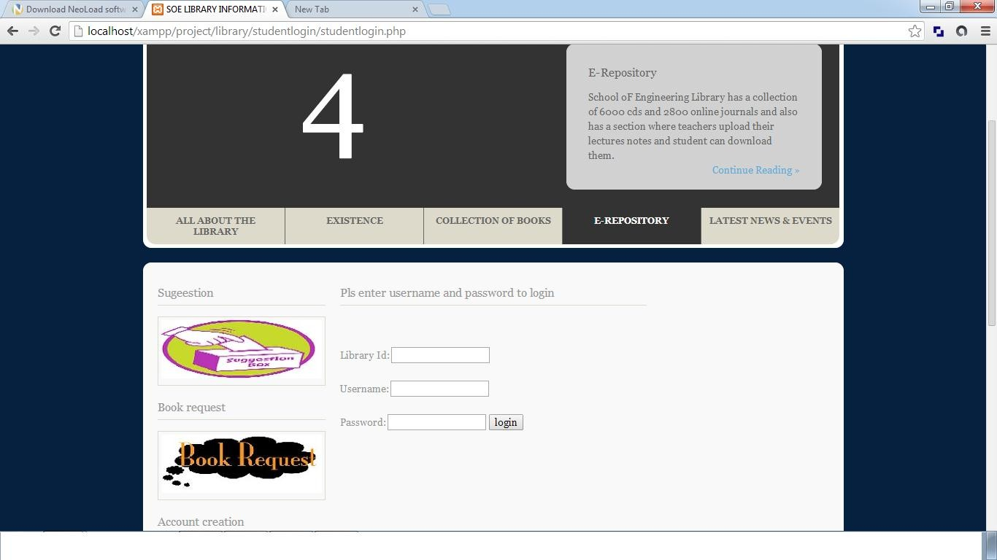**4.1.2 Screenshot for Student login**

#### 4.1.4 Book Module

SEARCH BOOK

ADD NEW BOOK

BOOK MAINTENANCE

The following module contains various facilities like add new book and search book. In the ‘add new book’ section if any new book comes in the Book then the librarian can add its specifications. Similarly if the user wants to search for a specific book then he/she can use search book option to do it.

#### Code For Adding New books

<?php

$con=mysqli_connect("localhost","root","","Book");

// Check connection

if (mysqli_connect_errno())

{

echo "Failed to connect to MySQL: " . mysqli_connect_error();

}

$sql="INSERT INTO books (code, bookname, author, publication, subject, numberofbooks)

VALUES

('$_POST[bookid]','$_POST[bookname]','$_POST[author]','$_POST[publication]','$_P OST[subject]','$_POST[numberofbooks]')";

if (!mysqli_query($con,$sql))

{

echo "error";

}

echo "successs";

mysqli_close($con);

?>

<?php

$con=mysqli_connect("localhost","root","","admin");

// Check connection

if (mysqli_connect_errno())

{

echo "Failed to connect to MySQL: " . mysqli_connect_error();

}

$sql="INSERT INTO newarrivals (code, bookname, author, publication, subject, numberofbooks,arrivaldate)

VALUES

('$_POST[bookid]','$_POST[bookname]','$_POST[author]','$_POST[publication]','$_P OST[subject]','$_POST[numberofbooks]','$_POST[arrivaldate]')";

if (!mysqli_query($con,$sql))

{

echo "error";

}

echo "successs"; mysqli_close($con);

?>

#### Code For issue book

<?php require'../include/connection1.php';

$result = mysqli_query($connection,"SELECT * FROM studentlogin"); while($row = mysqli_fetch_array($result))

{

$libid=$row['logid'] ;

$username= $row['username'];

$password= $row['password'];

$numbooks=$row['numbooks'];

}

if($numbooks>3)

{

echo"cannnot issue books limit exceeded";

}

else

{

$libid=$_POST['libid'];

$bookid=$_POST['bookid'];

$issuedate=$_POST['issuedate'];

$returndate=date_add($issuedate,date_interval_create_from_date_string("15 days"));

$sql="INSERT INTO issuebooks(libid,bookid,issuedate,returndate) VALUES

('$libid','$bookid','$issuedate','$returndate')"; mysqli_query($connection,"UPDATE studentlogin SET

numbooks=numbooks+1 WHERE logid='$libid'");

mysqli_query($connection,"UPDATE book SET numberofbooks=numberofbooks-1

WHERE code='$bookid'");

if (!mysqli_query($connection,$sql))

{

die('Error1: ' . mysqli_error($connection));

}

else

echo"added 1 record";

}

mysqli_close($connection);

?>

#### 4.1.6 Report Module

BOOK REPORT

TRANSACTION REPORT

TEACHER REPORT

REPORT

STUDENT REPORT

The following module contains various facilities like student report, teacher report, book report, and transaction report.

#### Code For Report Generation

#### Code For STUDENT REPORT

student");

<?php

require '../include/connection1.php';

$result = mysqli_query($connection,"SELECT * FROM

$count=mysqli_num_rows($result);

echo "<table border='1' style='width=100px'>

<tr>

<td>Bookid</td>

<td>Registration number</td>

<td>Name</td>

<td>Branch</td>

<td>Semester</td>

<td>Section</td>

<td>Year of adm</td>

</tr>"; while($count>0)

{

while($row = mysqli_fetch_array($result))

{echo "<tr>";

echo "<td>" . $row['libid'] . "</td>";

echo "<td>" . $row['regno'] . "</td>";

echo "<td>" . $row['stuname'] . "</td>";

**echo "<td>" . $row['branch'] . "</td>";**

echo "<td>" . $row['semester'] . "</td>";

echo "<td>" . $row['section'] . "</td>"; echo "<td>" . $row['yearofadm'] . "</td>";

echo"</tr>";

}

$count=$count-1;

}

mysqli_close($connection);

?>

</table>

# CHAPTER 6 CONCLUSION & FUTURE SCOPE

This website provides a computerized version of Book management system which will benefit the students as well as the staff of the Book.

It makes entire process online where student can search books, staff can generate reports and do book transactions. It also has a facility for student login where student can login and can see status of books issued as well request for book or give some suggestions. It has a facility of teacher’s login where teachers can add lectures notes and also give necessary suggestion to Book and also add info about workshops or events happening in our college or nearby college in the online notice board.

There is a future scope of this facility that many more features such as online lectures video tutorials can be added by teachers as well as online assignments submission facility , a feature Of group chat where students can discuss various issues of engineering can be added to this project thus making it more interactive more user friendly and project which fulfills each users need in the best way possible

# CHAPTER 7 REFERENCES

* <http://www.w3schools.com/html/html_intro.asp>
* <http://www.w3schools.com/css/css_background.asp>
* <http://www.w3schools.com/js/js_datatypes.asp>
* <http://www.w3schools.com/sql/sql_insert.asp>
* <http://www.w3schools.com/sql/sql_update.asp>
* <http://www.w3schools.com/php/php_forms.asp>
* Web development and application development by Ivan Byross BPB publications